MODULE 2

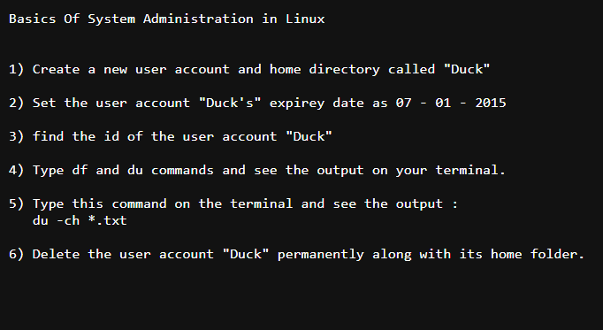

1)

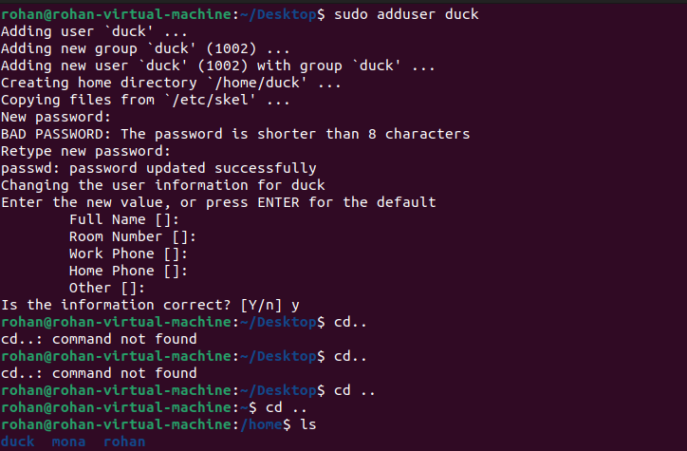
2) sudo usermod -e 2023-10-02 duck
3)
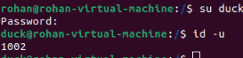
4)
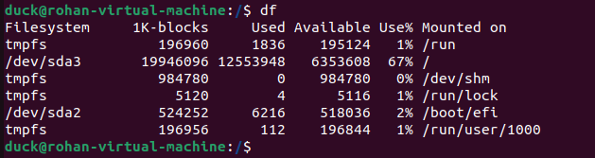
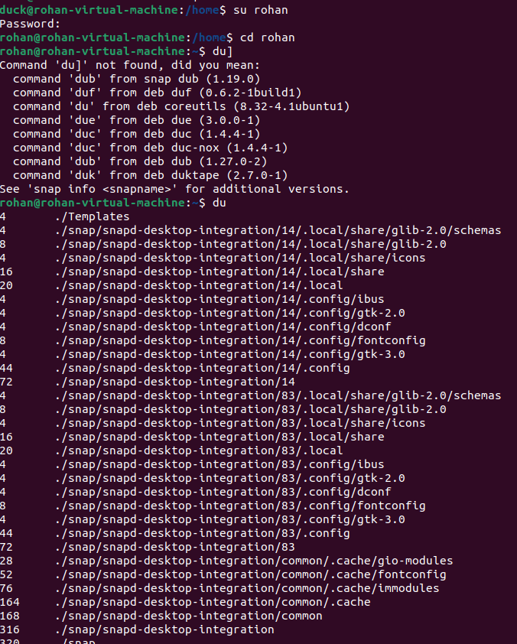

5)
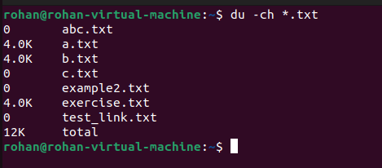

6)
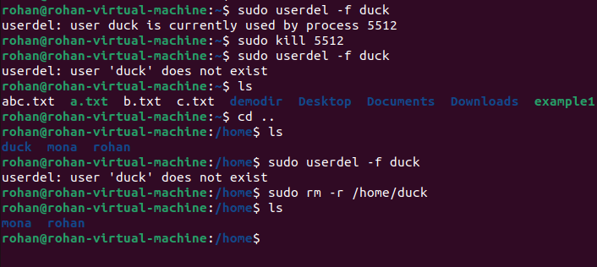

Simple Filters

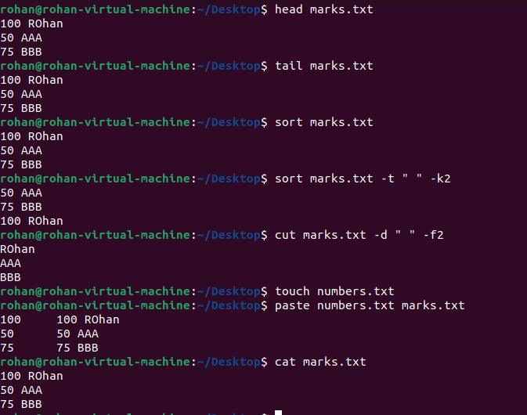

1. Try to get the first 10 lines from /etc/passwd
2. try to get just the first 3 lines from /etc/passwd

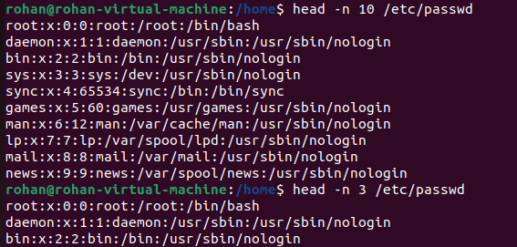

1. Try to get the Last 10 lines from /etc/passwd
2. Try to get just the Last 3 lines from /etc/passwd
3. Try to follow the log file /var/log/auth.log
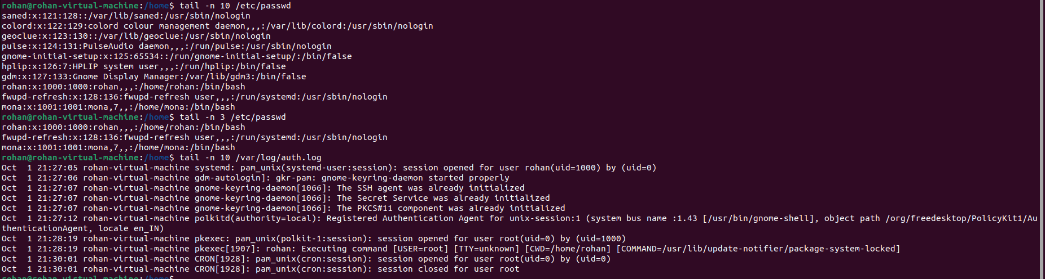

1. Try to sort the file /etc/passwd in assending order.
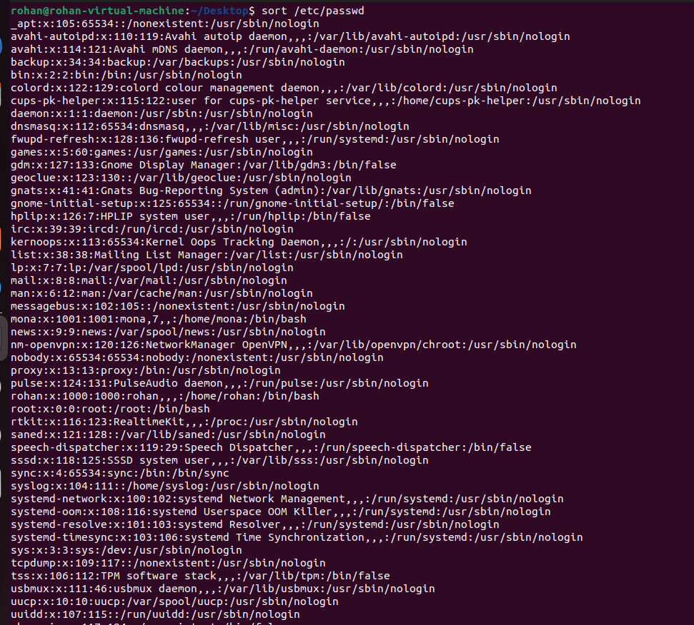
2. Try to sort the file /etc/passwd in decending order.
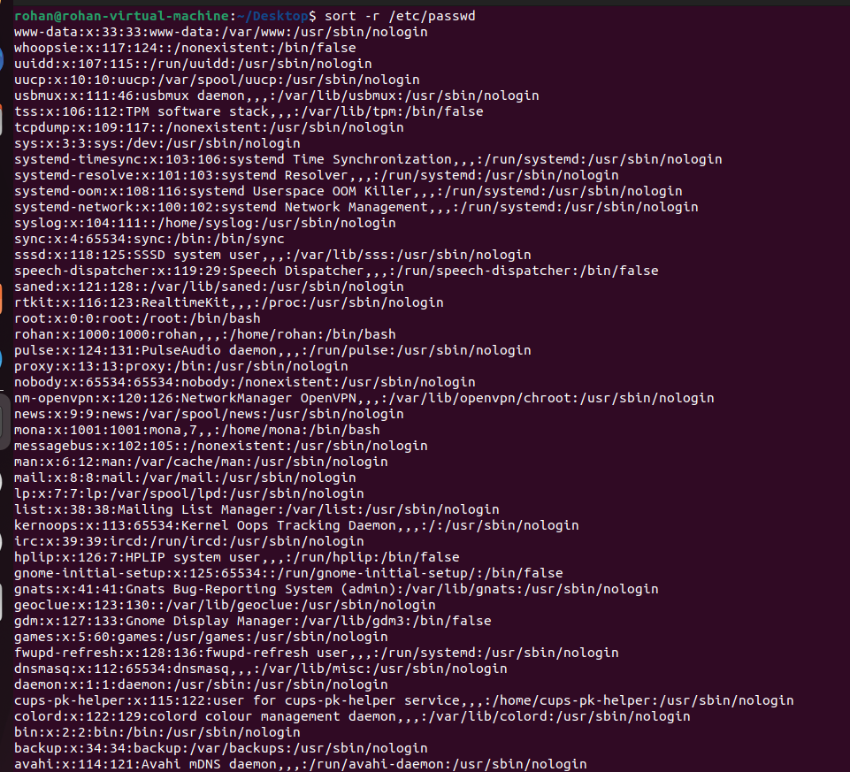
3. Try to sort the file /etc/passwd in assending order based on the 3rd column.
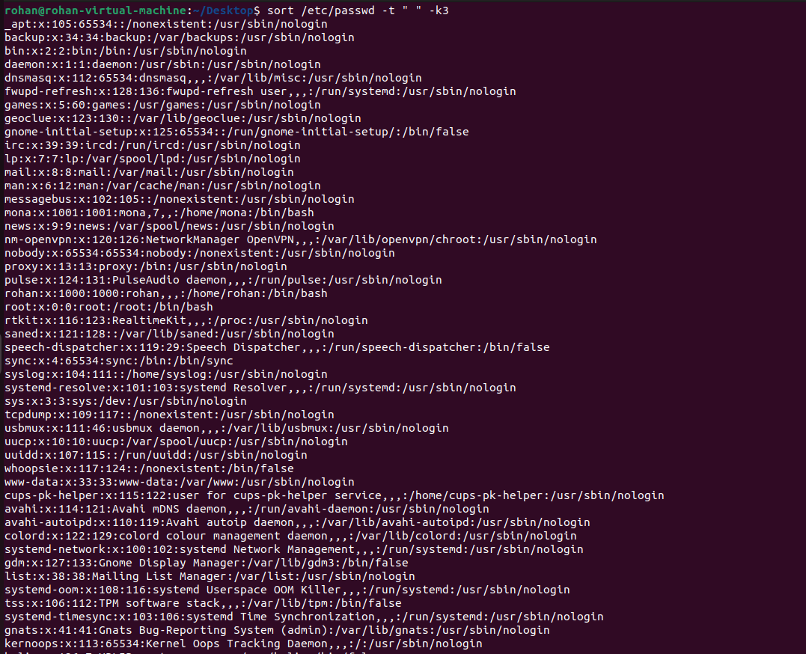
4. Try to sort the file /etc/passwd in assending order based on the 3rd column and ask sort to look at the thrid column as a whole number.
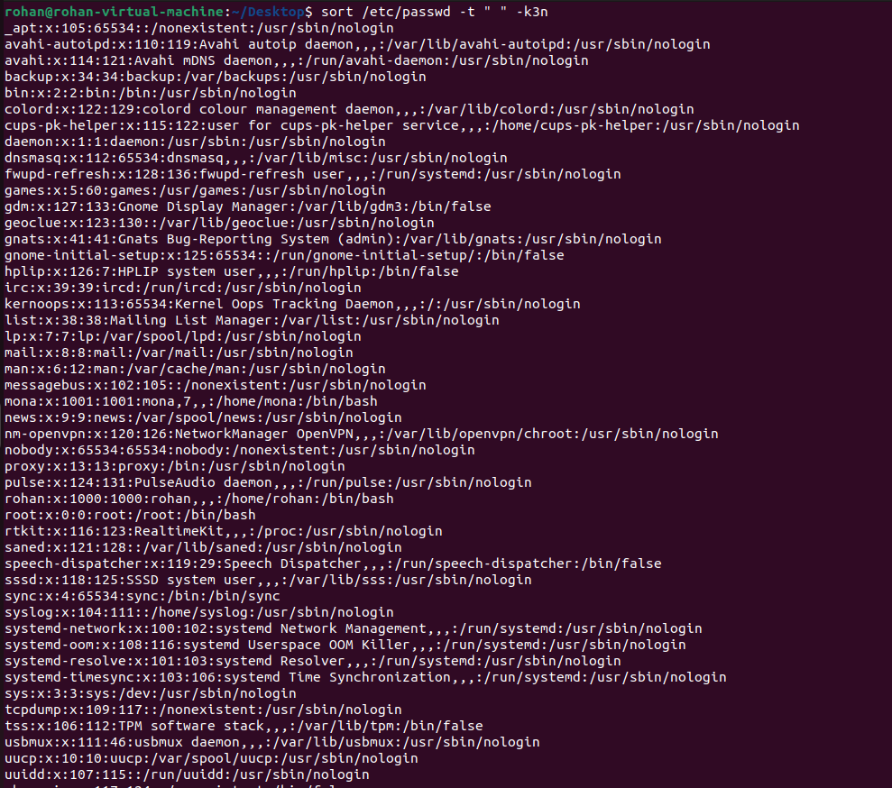
1. Try to cut just the usernames from the file /etc/passwd
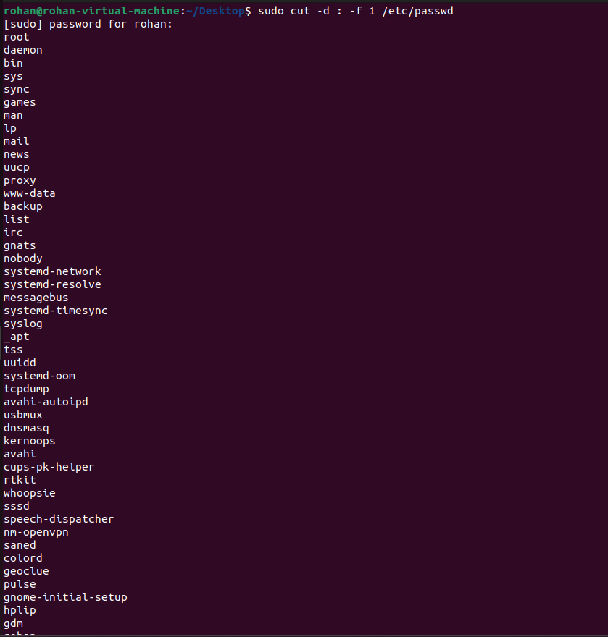

1. Create a file alphabets.txt and key in all the 2\6 alphabets each one in a new line.
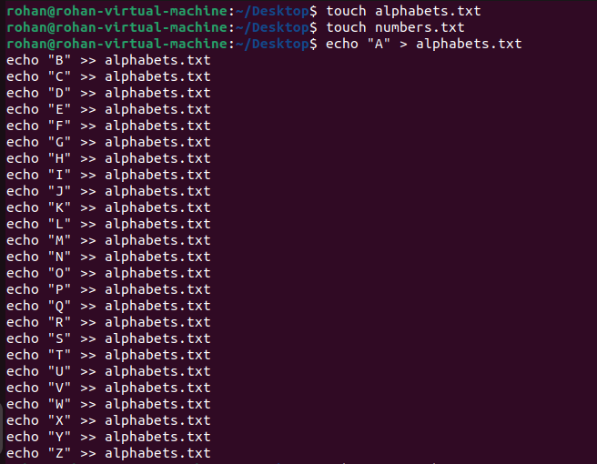
2. Create a file number.txt and key in 1 to 2\6 each one in a new line.
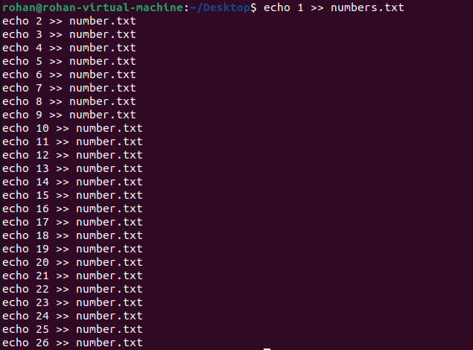
3. Try to paste those two files, to see which letter appears at what number. Paste alphabets.txt numbers.txt
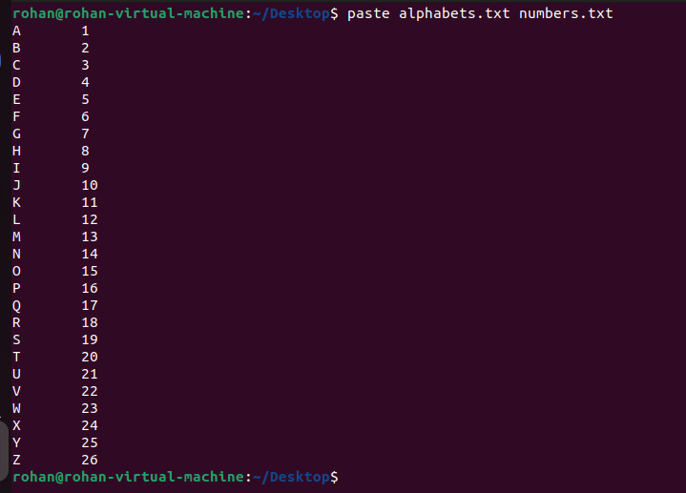

Grep Command

Explore some other commands like -E, + and ?
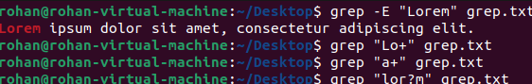

More on Grep
List those entries that are 5 letters long and starts with Y
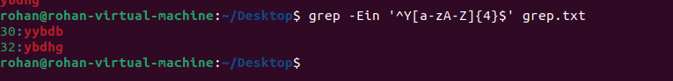

Sed Command
1) Use the same text file seddemo.txt
2) Try to print records from 6th to 12th line.
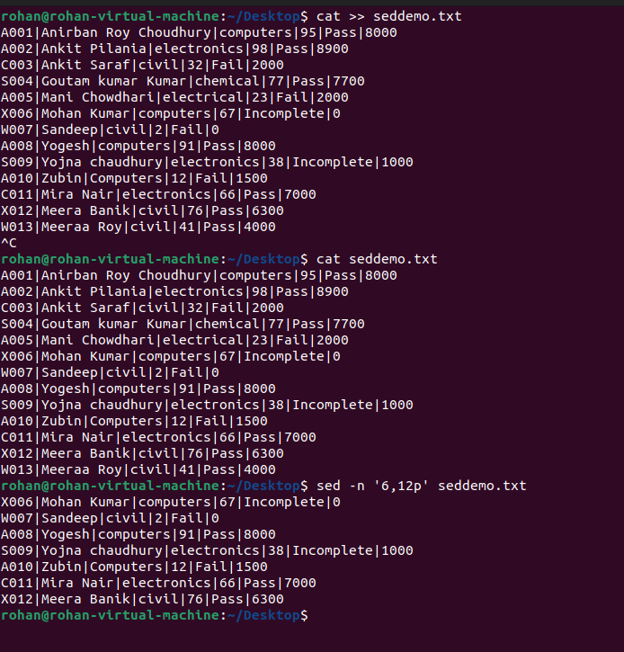

More on Sed Command
1) Use the same text file seddemo.txt
2) Try to replace or substitute name Ankit with Ashish
1) Use the same text file seddemo.txt
2) Try to replace or substitute name Ankit with Ashish

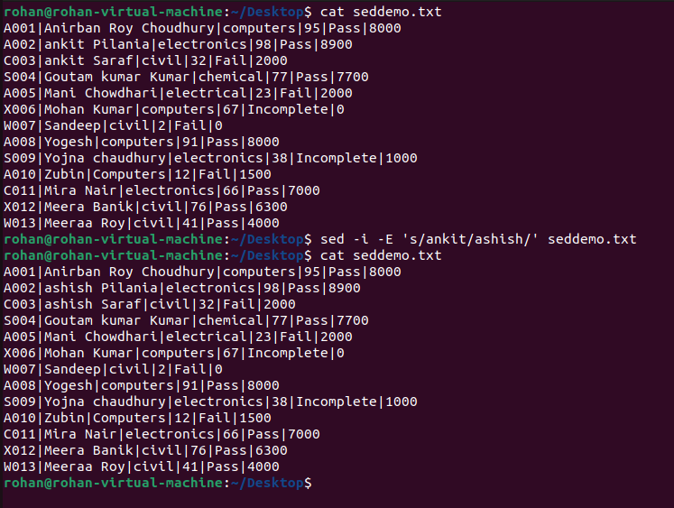

1) Use the same text file seddemo.txt
2) Try to replace or substitute name Ankit with Ashish

